

**Green University of Bangladesh**

**Department of Computer Science and Engineering (CSE)**

**Faculty of Sciences and Engineering**

**Semester: (Spring, Year:2021), B.Sc. in CSE (Day/Eve)**

**Course Title: Data Structure Lab**

**Course Code: CSE-106 Section: DA**

**Lab Project Name: Online Voting system**

**Student Details**

|  |  |
| --- | --- |
|  | **Name ID** |
| **1.** | **Aunika Farzana** 211902011 |

**Submission Date : 29 December 2021**

**Course Teacher’s Name : Md. Solaiman Mia**

**[For Teachers use only: Don’t Write Anything inside this box]**

**Lab Project Status**

**Marks: ………………………………… Signature: ..................... Comments:**

**.............................................. Date: ..............................**

Table of Contents

**3**

1.1 **Introduction:**

Electronic voting (also known as e-voting) is voting that uses electronic means to either aid or take care of casting and counting votes.

Depending on the particular implementation, e-voting may use standalone electronic voting machines (also called EVM) or computers connected to the Internet. It may encompass a range of internet services, from basic transmission of tabulated results to full-function online voting through common connectable household devices. The degree of Automation may be limited to marking a paper ballot, or may be a comprehensive system of vote input, vote recording, data encryption and transmission to servers, and consolidation and tabulation of election results.

**1.2 Design Goals/Objective:**

**This project’s main aim is to provide a safe and secure voting system environment, where admin can allow the user to vote, and admin can declare a result.**

* **Registration ( Name, birth and id)**
* **Admin login ( username and password)**
* **User Voting ( voter id and voting)**
* **Result declaration**

**2.1 Code Implementation**

#include <stdio.h>

#include <stdlib.h>

#include <string.h>

#include <windows.h>

typedef struct voter_information

{

char national[20];

char name[50];

char birth_date[15];

struct voter_information *next;

} node;

node *head;

node *space,*start=NULL;

node *search(char x[],char y[],char z[],node *,int *);

node *voter_insert(node *);

node *main_logs(node *);

void admin();

void winner();

void exi();

void voting();

void not_again();

void stop();

void show();

int count=0,R=3,vote=0;

int vote1=0,vote2=0,vote3=0,vote4=0,vote5=0;

int main()

{

while(1)

{

system("cls");

printf("\n\n\n");

printf("\t ** WELCOME TO THE ONLINE VOTING PORTAL ** \n\n");

printf("\t *********************************************** \n\n\n\n\n");

printf(" \t\t ***Please Enter One(1) for logging vote main Logs*** \n\n\n");

int BB;

scanf("%d",&BB);

if(BB==1)

{

start= main_logs(start);

}

}

return 0;

}

node *main_logs(node *start)

{

system("cls");

printf("\n\n\n");

printf(" \t\t\t1. FOR VOTE ENTRY \n");

Sleep(300);

printf(" \t\t\t2. FOR ADMIN PANEL \n");

Sleep(300);

printf(" \t\t\t3. FOR WINNER \n");

printf(" \t IF YOUR CREDENTIALS MATCHES WITH THOSE IN THE VOTER LIST THEN ONLY YOU CAN GIVE YOUR VOTE OTHERWISE YOU CAN NOT \n\n\n");

Sleep(500);

printf(" \t ********So Please Enter********\n\n\n");

int T;

scanf("%d",&T);

if(T==1)

{

start= voter_insert(start);

}

if(T==2)

{

admin();

}

if(T==3)

{

winner();

}

if(T!=1||T!=2||T!=3)

{

main_logs(start);

}

return start;

}

node *voter_insert(node *start)

{

int UNIVERSAL=0;

int *z;

z = &UNIVERSAL;

node *temp;

char name[50],birth_date[15],national[20];

system("cls");

printf("\n\n\n\n");

printf("\t IF NATIONAL ID, YOUR NAME AND YOUR DATE OF BIRTH MATCHES THEN YOU CAN GIVE YOUR VOTE OTHERWISE NOT\n\n");

Sleep(300);

printf("\t\t\t ID YOU DO WRONG %d TIMES, THE PORTAL WILL BE CLOSED AUTOMATICALLY\n\n\n",R);

Sleep(300);

printf("\t\tPlease \n");

Sleep(300);

printf("\t\t\tEnter your NATIONAL ID number ");

gets(national);

gets(national);

printf("\t\t\tEnter Your NAME ");

gets(name);

printf("\t\t\tEnter Your BIRTH DATE in dd-mm-yyyy format");

gets(birth_date);

temp=(node *)malloc(sizeof(node));

strcpy(temp->national,national);

strcpy(temp->name,name);

strcpy(temp->birth_date,birth_date);

temp->next=NULL;

head=temp;

while(temp!=NULL)

{

if((strcmp(temp->national,"10001")==0&& strcmp(temp->name,"Rajat Kumar")==0 &&strcmp(temp->birth_date,"31-03-1999")==0) ||

(strcmp(temp->national,"10002")==0&& strcmp(temp->name,"Goutam Kumar Bhadani")==0 &&strcmp(temp->birth_date,"01-01-1999")==0)||

(strcmp(temp->national,"10003")==0&& strcmp(temp->name,"Gautam Kumar")==0 &&strcmp(temp->birth_date,"12-10-1999")==0)||

(strcmp(temp->national,"10004")==0&& strcmp(temp->name,"Kundan Kumar")==0 &&strcmp(temp->birth_date,"08-12-1999")==0)||

(strcmp(temp->national,"10005")==0&& strcmp(temp->name,"Aniket Arora")==0 &&strcmp(temp->birth_date,"28-08-1999")==0)||

(strcmp(temp->national,"10006")==0&& strcmp(temp->name,"Dipika Singh")==0 &&strcmp(temp->birth_date,"20-10-2000")==0)||

(strcmp(temp->national,"10007")==0&& strcmp(temp->name,"Avinash Kumar")==0 &&strcmp(temp->birth_date,"02-03-1999")==0)||

(strcmp(temp->national,"10008")==0&& strcmp(temp->name,"Ravi Raj")==0 &&strcmp(temp->birth_date,"26-12-1999")==0)||

(strcmp(temp->national,"10009")==0&& strcmp(temp->name,"Shubham Kumar")==0 &&strcmp(temp->birth_date,"02-01-1999")==0)||

(strcmp(temp->national,"10010")==0&& strcmp(temp->name,"Subham Kumar")==0 &&strcmp(temp->birth_date,"03-01-1999")==0))

{

R=3;

start=search(temp->national,temp->name,temp->birth_date,start,&UNIVERSAL);

if(UNIVERSAL==0)

{

voting();

}

else

{

not_again();

}

}

else

{

R--;

if(R==0)

{

stop();

break;

}

printf("\n\n\n\n");

printf("\tYour AADHAR ID or NAME or DATE OF BIRTH is wrong\n\n");

Sleep(300);

printf("\t\t\tPlz Re-Enter\n\n");

Sleep(300);

system("pause");

start= main_logs(start);

}

temp=temp->next;

}

return start;

}

void voting()

{

system("cls");

printf("\n\n\n\n");

printf("\t\t * * * * * LIST OF CANDIDATES * * * * * \n\n\n");

Sleep(300);

printf("\t\t\t NAME & THEIR RESPECTIVE SYMBOL\n\n");

Sleep(300);

printf("\t\t\t 1.Sheikh Hasina 1.Boat\n");

Sleep(300);

printf("\t\t\t 2.Begum Khaleda Jia 2.Sheaf of Rice\n");

Sleep(300);

printf("\t\t\t 3.Rowsan Ershad 3.Plow\n");

Sleep(300);

printf("\t\t\t 4.Rusmita Halim Chaity 4.Broomstick\n");

Sleep(300);

printf("\t\t\t 5.Md Sultanul Ovi 5.Wheel\n\n\n");

int B,j;

printf("\t\t\t Plzz, \n");

printf("\t\t\t Enter Your Choice \n");

for(j=1; j<=1; j++)

{

scanf("%d",&B);

if(B==1)

{

vote1++;

printf("\n\n\t\t\t\tYOU HAVE SUCCESSFULLY GIVEN YOUR VOTE TO SHEIKH HASINA\n");

break;

}

if(B==2)

{

vote2++;

printf("\n\n\t\t\t\tYOU HAVE SUCCESSFULLY GIVEN YOUR VOTE TO BEGUM KHALEDA JIA\n");

break;

}

if(B==3)

{

vote3++;

printf("\n\n\t\t\t\tYOU HAVE SUCCESSFULLY GIVEN YOUR VOTE TO ROWSAN ERSHAD\n");

break;

}

if(B==4)

{

vote4++;

printf("\n\n\t\t\t\tYOU HAVE SUCCESSFULLY GIVEN YOUR VOTE TO RUSMITA HALIM CHAITY\n");

break;

}

if(B==5)

{

vote5++;

printf("\n\n\t\t\t\tYOU HAVE SUCCESSFULLY GIVEN YOUR VOTE TO MD SULTANUL OVI\n");

break;

}

if(B!=1||B!=2||B!=3||B!=4||B!=5)

{

printf("\n\t\t************* INVALID CHOICE ENTERED**************\t\t\n");

printf("\n\t\t\tENTER AGAIN\t\t\t\n");

}

}

printf("\n\n**************************THANK YOU***************************\n\n");

printf("press any key");

getch();

}

void admin()

{

int B;

printf("\n\n\n\n");

printf("\t\t\t\t\tEnter Your Password To Unlock The Admin Panel\n\n");

scanf("%d",&B);

if(B==3692)

{

show();

}

else

{

printf("Wrong Password\n");

}

}

void show()

{

int G;

system("cls");

printf("\n\n\n\n");

printf("\t\t\tPresent Vote Count :\n\n");

Sleep(500);

printf("\t\t\t Sheikh Hasina is on %d Votes\n",vote1);

Sleep(500);

printf("\t\t\t Begum Khaleda Jia is on %d Votes\n",vote2);

Sleep(500);

printf("\t\t\t Rowsan Ershad is on %d Votes\n",vote3);

Sleep(500);

printf("\t\t\t Rusmita Halim Chaity is on %d Votes\n",vote4);

Sleep(500);

printf("\t\t\t Md Sultanul Ovi is on %d Votes\n\n\n\n",vote5);

Sleep(500);

printf("\t\t\t\t\tEnter Any Key For Main Logs\n\n\t\t\t\t\t\t\tOR\n\n\t\t\t\t\tENTER THE SPECIAL PASSWORD TO CLOSING VOTING PORTAL\n ");

scanf("%d",&G);

if(G==1234)

exi();

else

main_logs(start);

}

void winner()

{

system("cls");

printf("\n\n\n\n");

if(vote2<vote1 && vote3< vote1 && vote4<vote1 && vote5<vote1)

printf("\t\t\tThe present Winner is Sheikh Hasina and she has got %d votes\n\n\n\n",vote1);

if(vote1<vote2 && vote3< vote2 && vote4<vote2 && vote5<vote2)

printf("\t\t\tThe present Winner is Begum Khaleda Jia and she has got %d votes\n\n\n\n",vote2);

if(vote1<vote3 && vote2< vote3 && vote4<vote3 && vote5<vote3)

printf("\t\t\tThe present Winner is Rowsan Ershad and she has got %d votes\n\n\n\n",vote3);

if(vote1<vote4 && vote2< vote4 && vote3<vote4 && vote5<vote4)

printf("\t\t\tThe present Winner is Rusmita Halim Chaity and she has got %d votes\n\n\n\n",vote4);

if(vote1<vote5 && vote2< vote5 && vote3<vote5 && vote4<vote5)

printf("\t\t\tThe present Winner is Md Sultanul Ovi and he has got %d votes\n\n\n\n",vote5);

printf("\t\t\t\tEnter Any Key for Main Log\n\n");

getch();

main_logs(start);

}

void stop()

{

system("cls");

printf("\n\n\n\n");

printf("\t\t\t (:-SORRY YOU ENTERED WRONG CREDENTIALS FOR THREE(3) TIMES IN A ROW -:) \n\n\n");

Sleep(500);

printf("\t\t\t Plz try again After A few Moment\n\n\n");

Sleep(500);

printf("\t\t\t * * Thank You * * \n\n\n");

Sleep(500);

printf("press any key");

getch();

}

void not_again()

{

int A;

system("cls");

printf("\n\n\n\n");

printf("\t\t\t *YOU HAVE GIVEN YOUR VOTE SUCCESSFULLY* \n\n\n");

Sleep(300);

printf("\t\t\t *YOU CANNOT GIVE YOUR VOTE MORE THAN ONCE* \n\n\n");

Sleep(300);

printf("\t\t\t If You want to see present winner Enter One(1) or Enter Any Other Key for Main Logs\n\n");

Sleep(300);

scanf("%d",&A);

if(A==1)

{

winner();

}

else

{

main_logs(start);

}

}

void exi()

{

system("cls");

printf("\n\n\n\n\n");

Sleep(500);

printf("\t\t\t *YOU ARE NOW EXITING THE PORTAL* \n\n\n");

Sleep(1000);

printf("\t\t\t * * Thank You For Using This ONLINE PLATFORM For VOTING * * \n\n\n");

Sleep(1000);

exit(0);

}

node *search(char x[],char y[],char z[],node *start,int *Y)

{

*Y=0;

node *t,*space;

if(start==NULL)

{

space=(node*)malloc(sizeof(node));

strcpy(space->national,x);

strcpy(space->name,y);

strcpy(space->birth_date,z);

start=space;

space->next=NULL;

}

else

{

t=start;

while(t!=NULL)

{

if((strcmp(t->national,x)==0&& strcmp(t->name,y)==0 &&strcmp(t->birth_date,z)==0))

{

*Y=1;

break;

}

t=t->next;

}

if(*Y==0)

{

space=(node*)malloc(sizeof(node));

strcpy(space->national,x);

strcpy(space->name,y);

strcpy(space->birth_date,z);

t=space;

space->next=NULL;

}

}

return start;

}

**Output**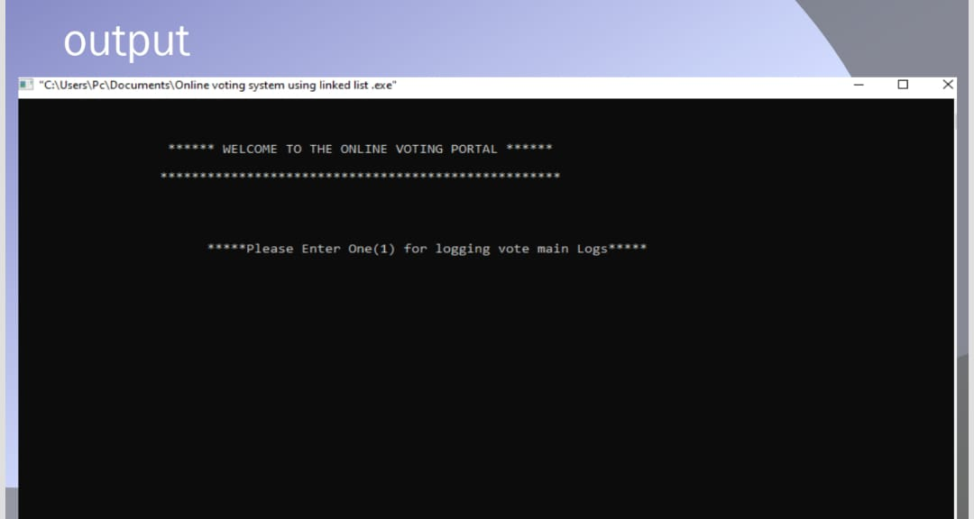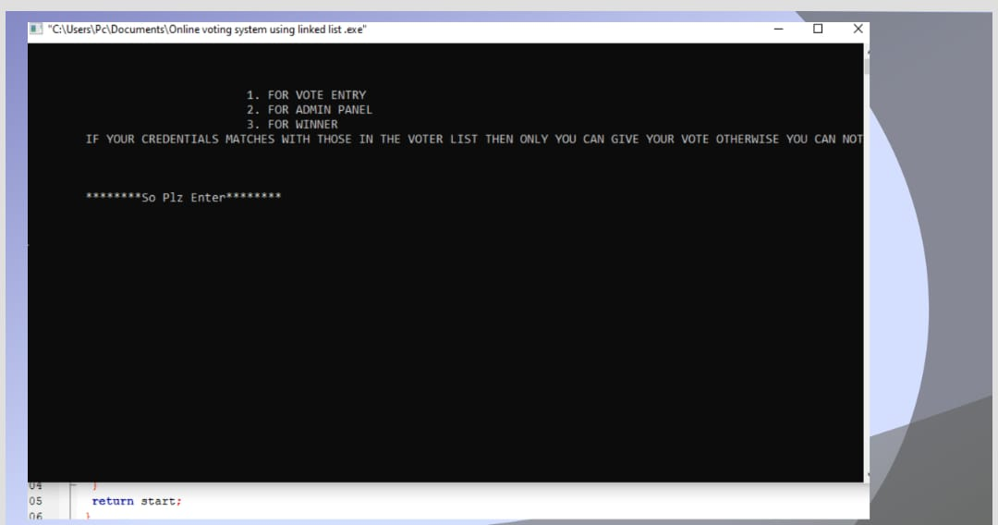

# **|** Page

**3.1: Tools and Technologies:**

* **To code we will use visual code software.**
* **In the code we will use a stack array, loop, statement-if else, switch,case.**
* **I will use the link list implementation of stack code.**
* **And we will use many more functions**

**4.1: Conclusion:**

**This voting system is a very standard voting system. we use this voting system ,we can give a user a safe and good voting environment and safe results and provide advanced features.**

**4.2: scope of future work:**

**Given a better security in the future. This project is converted to a file…….**

**References:**

**No**

# **|** Page